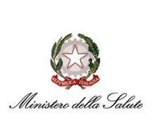 | 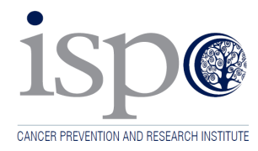

Final Workshop of the International

Partnership Project

“Best Practices in smoking prevention among youths in Mediterranean Countries”

15,16 JUNE 2015 - ROME

Ministry of Health

Conference Centre

Viale Giorgio Ribotta, 5

REGISTRATION FORM
(please return this form to the following email f.cazzagon@myegosrl.it by June 15th)

LAST NAME
FIRST NAME
COUNTRY
ORGANIZATION
TELEPHONE NUMBER
MOBILE PHONE
EMAIL ADDRESS

Date________________ Signature_____________________

In compliance with Organic law 13/2003, dated on Jun 2003, 30th, related to data protection, we inform you that the personal information provided by you in this form will be stored in a database controlled by My Ego S.r.l. and used to promote the mentioned event, or related events and future editions of this event. If you wish to exercise your rights to access, rectify, cancel and oppose the treatment of your data, please contact, My Ego S.r.l. Via Ugo de Carolis, 154 - 00136 Rome - Italy - Tel. +39.06.59604371- Mobile +39.366.8727434 – info@myegosrl.it.

