Renewal of national authorisations for biocidal products containing difethialone or difenacoum

Introduction
In general any asset owner or representative of an asset owner, wishing to seek a renewal of a national authorisation must submit an application at least 550 days before the expiry date of the authorisation through R4BP 3. If the application is valid, ECHA will forward the application to the receiving MSCA.
For difethialone-containing product, if the BPR had already entered into operation, authorisation holders would have had to submit their applications before 29th April 2013. It is therefore foreseen that the authorisation holders submit their applications as soon as possible after 1st September 2013 for biocidal products containing difethialone. For biocidal products containing difenacoum, the deadline for making the application is 27th September 2013.

Submitting an application for renewal of national authorisation via major changes submission wizard
This sub-chapter covers what supporting documents need to be included in the submission wizard and how to submit your application via R4BP 3. For more detailed submission instructions please see Manual 2 – Using R4BP 3 for biocide applications.

Supporting documents

You need to fill in the

application form - renewal of a national authorisation
and upload it as supporting document (see Step 4 in section 1.2.2). If additional supporting documents are required by the receiving MSCA, add them in the same step of the submission wizard. In case the receiving MSCA asks for an SPC, please upload it in the respective step of the submission wizard (see Step 3 in section 1.2.2).

Application wizard for renewal of national authorisations
(via NA-MAC)
Currently, the application wizard that must be used to apply for a renewal of a national authorisation is via the application process for ‘National authorisation major change on request’. Once the application has entered this process workflow, all renewal of national authorisation applications will be reassigned to the correct process workflow once the renewal process has been implemented.
To launch the correct application wizard, click on the ‘ASSETS’ tab on the R4BP 3 taskbar. Then, search for the specific national authorisation (NA) asset that shall be renewed by filling in some search criterion (e.g. the asset number, asset type (NA), etc.). Clicking on the asset number hyperlink in the ‘Assets list’ will open the ‘Asset details’ page. On this page click ‘Create new case’ and then select ‘National authorisation major change on request’ from the list of processes (Figure 1).
Figure 1: Launching the application wizard for NA-MAC
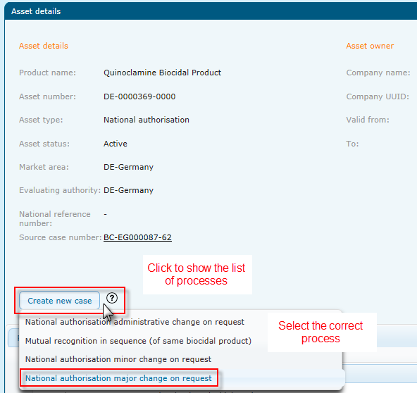
The application wizard will guide you through the various steps of the application form. When navigating through the wizard, actions have to be performed in a particular order. Forward navigation occurs by clicking on the ‘Next’ button and is disabled until the mandatory fields, marked with an asterisk (), have been filled in correctly. Backward navigation occurs by pressing the ‘Back’ button and allows you to change previously saved data. You can cancel the process at any point by pressing the ‘Cancel’ button.
The wizard will guide you through six steps that are further described in Manual 2 - Using R4BP 3 for biocide applications:
- Set submission details (of the case owner): Select a contact person from the drop down list. Note that the asset owner, evaluating authority and payment details cannot be altered.
- Upload dossier: The wizard will provide you with the opportunity to upload a IUCLID 5 dossier (.i5z format). Click on the ‘+Browse’ button and select the dossier you want to upload. Click on ‘Upload’ to upload the dossier. Choose a ‘language’ and an ‘access level’ from the drop down list next to the uploaded dossier.
- Upload SPC: In the next step, you are able to upload an SPC if requested by the receiving MSCA in an editable format (e.g. word document). Click on the ‘+Browse’ button and select the SPC file you want to upload. Click on ‘Upload’ to upload the dossier. Choose a ‘language’ and an ‘access level’ from the drop down list next to the uploaded SPC.
- Upload supporting document(s): Click on the ‘+Browse’ button and select the file(s) you want to upload, i.e. application form on the renewal of a national authorisation as supporting document. Click on ‘Upload’ to upload the document. If additional supporting documents are required by the receiving MSCA, add them at this step. Choose a ‘language’ and an ‘access level’ from the drop down list next to the uploaded file.
- Confirm submission: Carefully verify that the data entered in the previous steps is correct. If the information entered is not correct, you can update any of the fields by clicking the ‘Back’ button. When all of the information is verified, confirm the legal declaration and submit your application.
- Receive the submission number.

Further information on how to track the status of your application in R4BP 3, is summarised in the Summary sheet 3 of this manual.

Submission Checklist
- Ensure you have selected the correct application type from the ‘Create new case’ process list found through the appropriate NA asset, ‘National authorisation major change on request’.
- Is the case owner and contact person indicated correctly (Step 1 of the wizard)?
- Ensure you have uploaded the application form on the renewal of a national authorisation as supporting document. Ensure you have uploaded any further relevant supporting documents in their correct formats as requested by the receiving MSCA.

